16.44: For a stationary source, 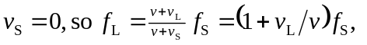
This is negative because the listener is moving away from the source.

